**Baseline: For credit level**

* **Clear and correct code** to most programming activities
  + **Claim**: Yes, I have produced clean and correct code.
  + **Overview**: This has been a significant challenge, especially due to the fact that I was already affiliated with different coding styles, however it’s important to be flexible.
  + **Evidence**

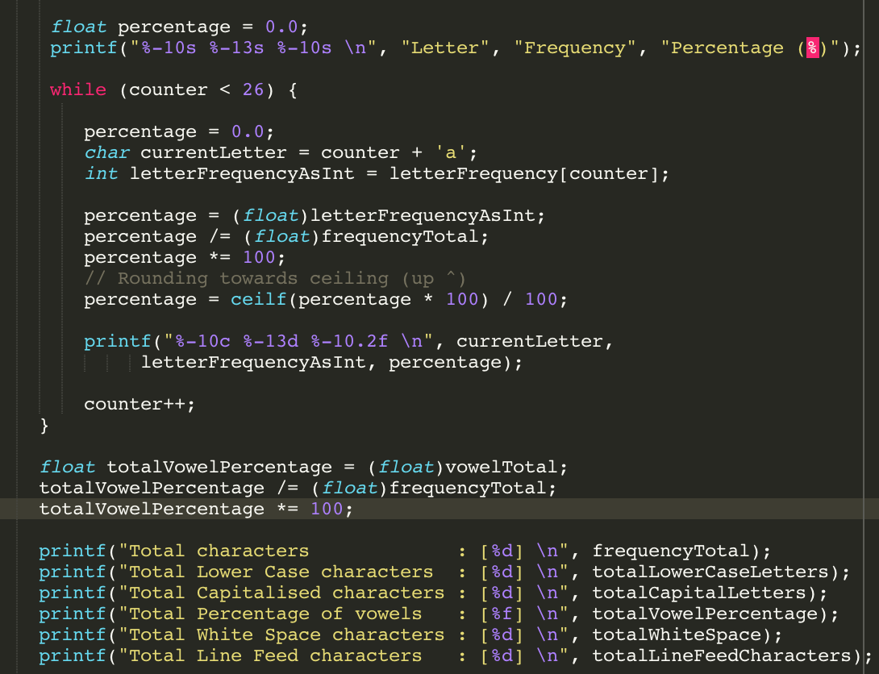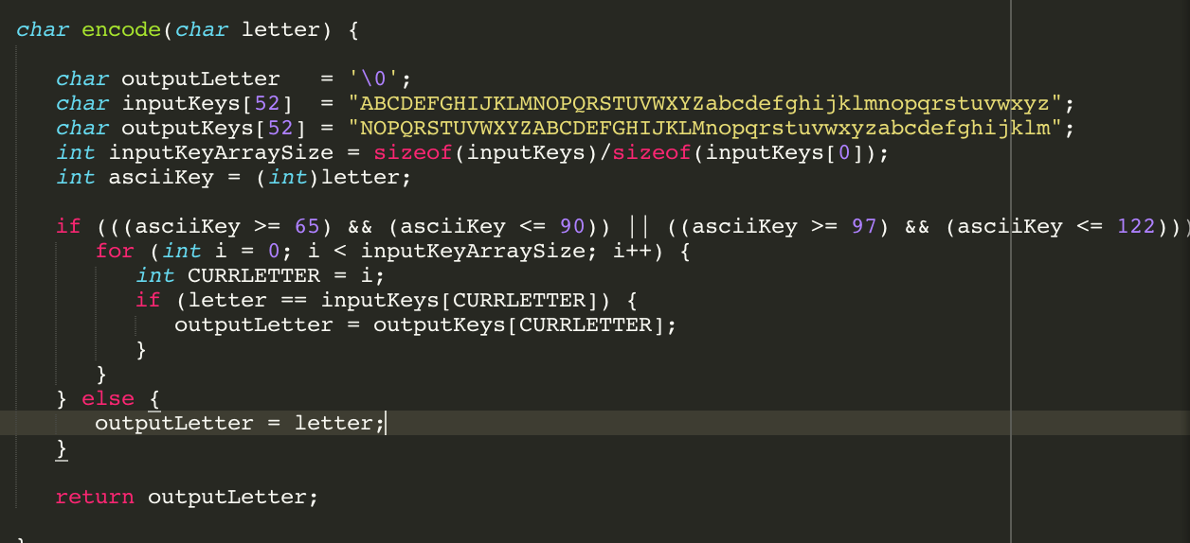

* **Clear and correct code** for the assignments
  + **Claim**: Yes clear and correct code was used for the assignments.
  + **Overview**: I made a personal goal to make my code for every assignment and activity readable to everyone.
  + **Evidence**

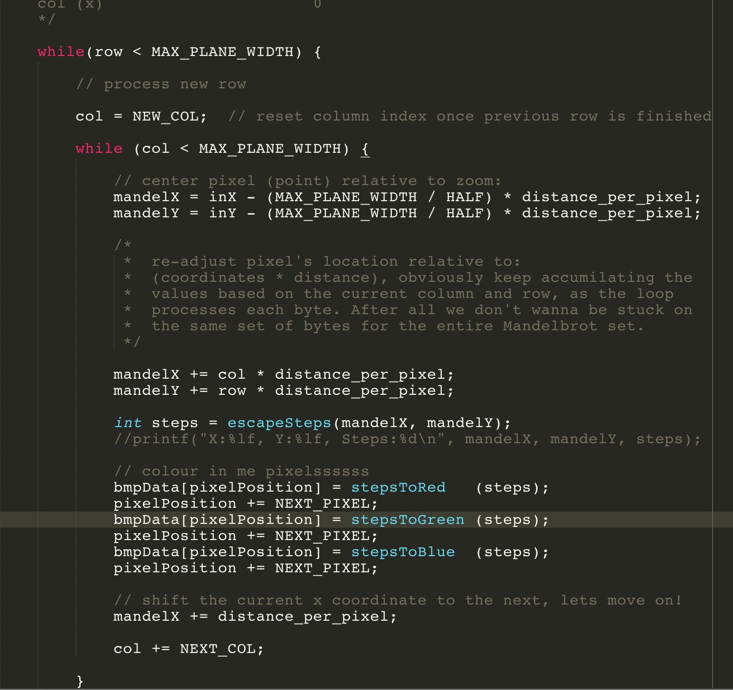

* Own contribution to the project (Task 2B and other projects) is **clear and correct code**
  + **Claim**: Yes, I have contributed greatly to the Mandelbrot activity.
  + **Overview**: I was actually the one to do all the work in my Task2B group, however it was a great experience and I loved the work with fractals and web servers.
  + **Evidence**

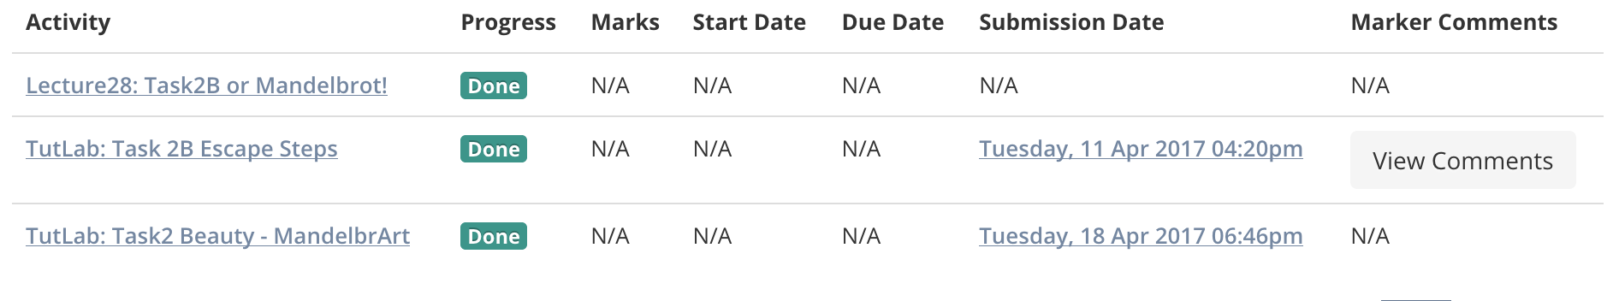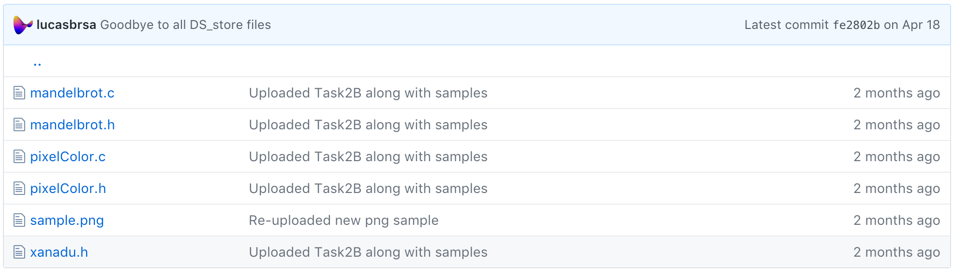

* Evidence of a **commitment to testing**
  + **Claim**: Yes, I have committed to testing all my programs.
  + **Overview**: I have change the way I approach activities and function stubs. Always making sure to approach using a test-driven method, writing lots of tests and making them extensive.
  + **Evidence**

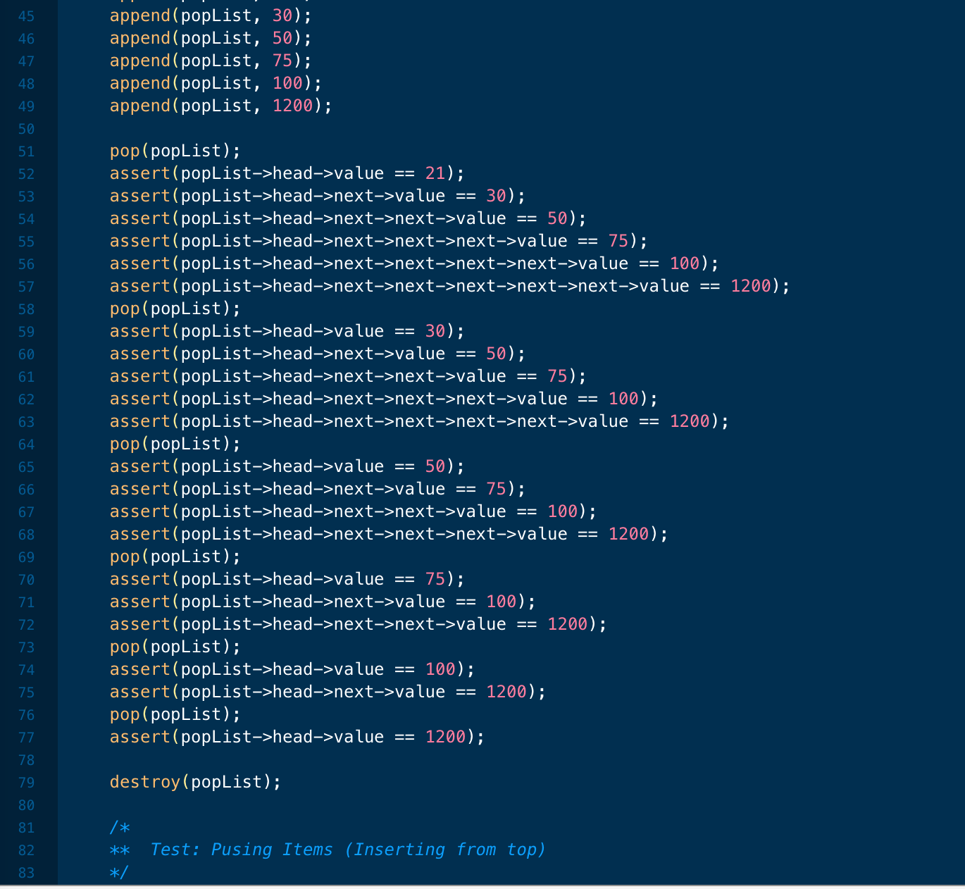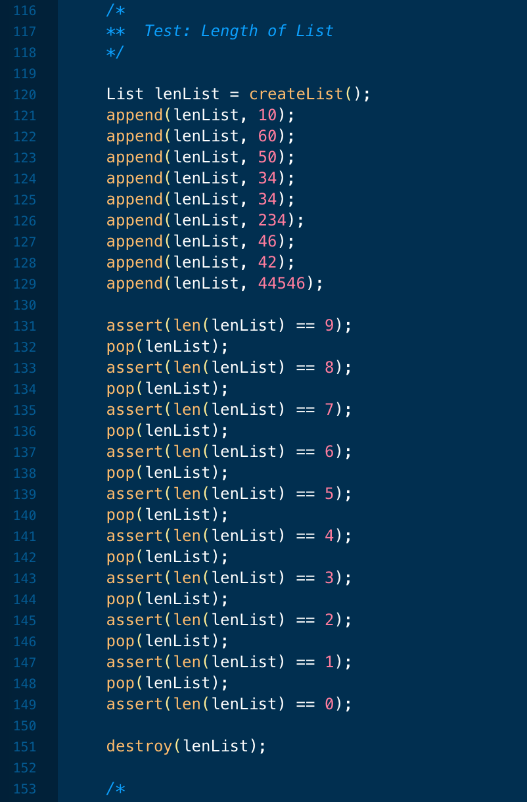

**Additional factors: look for:**

* Evidence of **planning and reflection on craftsmanship** and code quality and correctness
  + **Claim**: Yes, I have planned and reflected on my craftsmanship.
  + **Overview**: I owe an unpayable debt to the C style guide and the craftsmanship principles. I gave all my old verbose code an 100 point restoration and now it actually looks like something that should be read.
  + **Evidence**

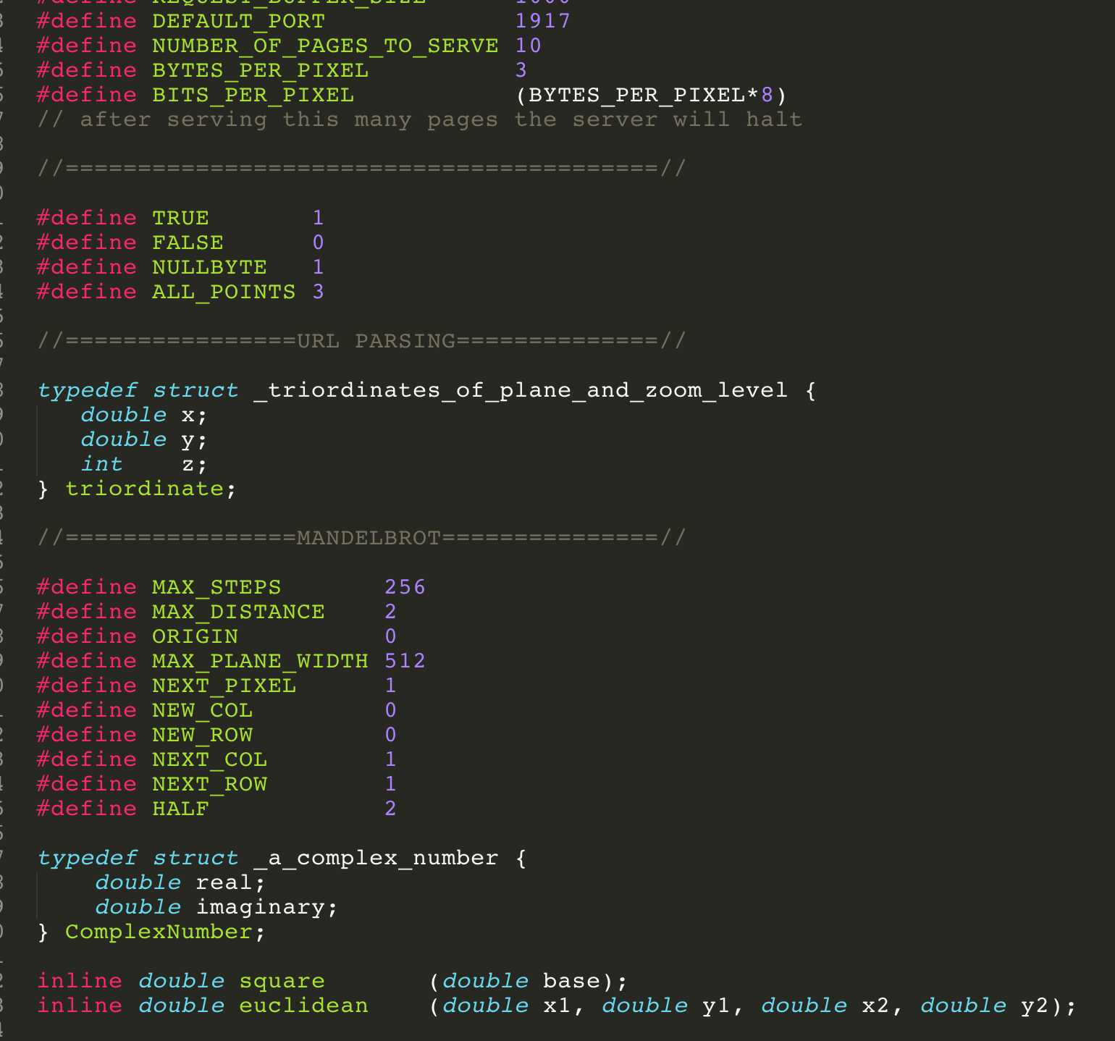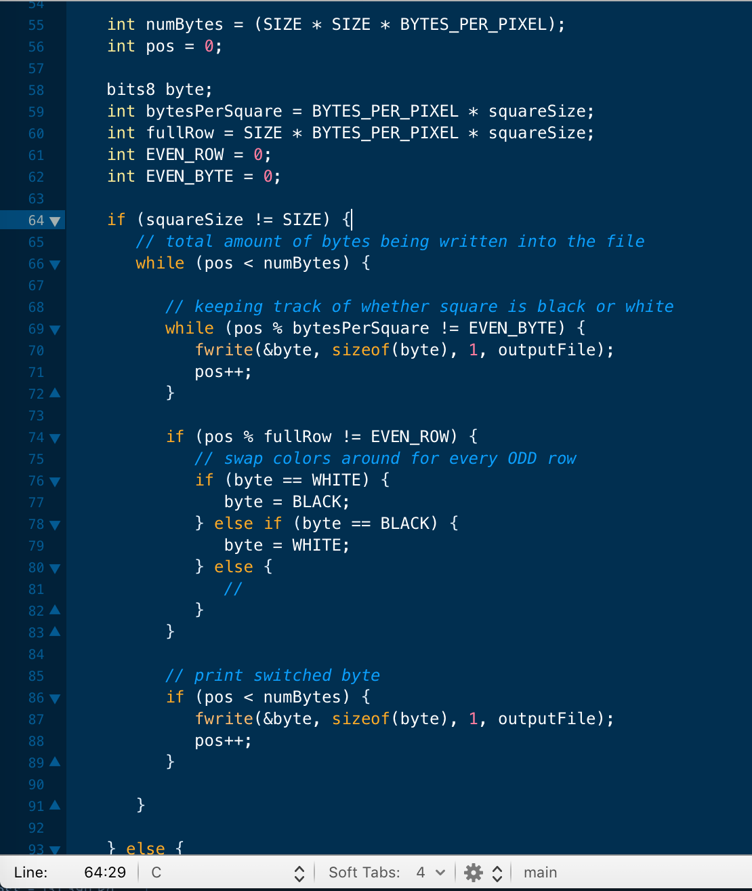

* Evidence of **carrying out planning**
  + **Claim**: Yes, I have carried out my planning.
  + **Overview**: Planning is useless without implementation, hence why it’s important to carry out all plans made or they never leave the drawing board in the first place.
  + **Evidence**

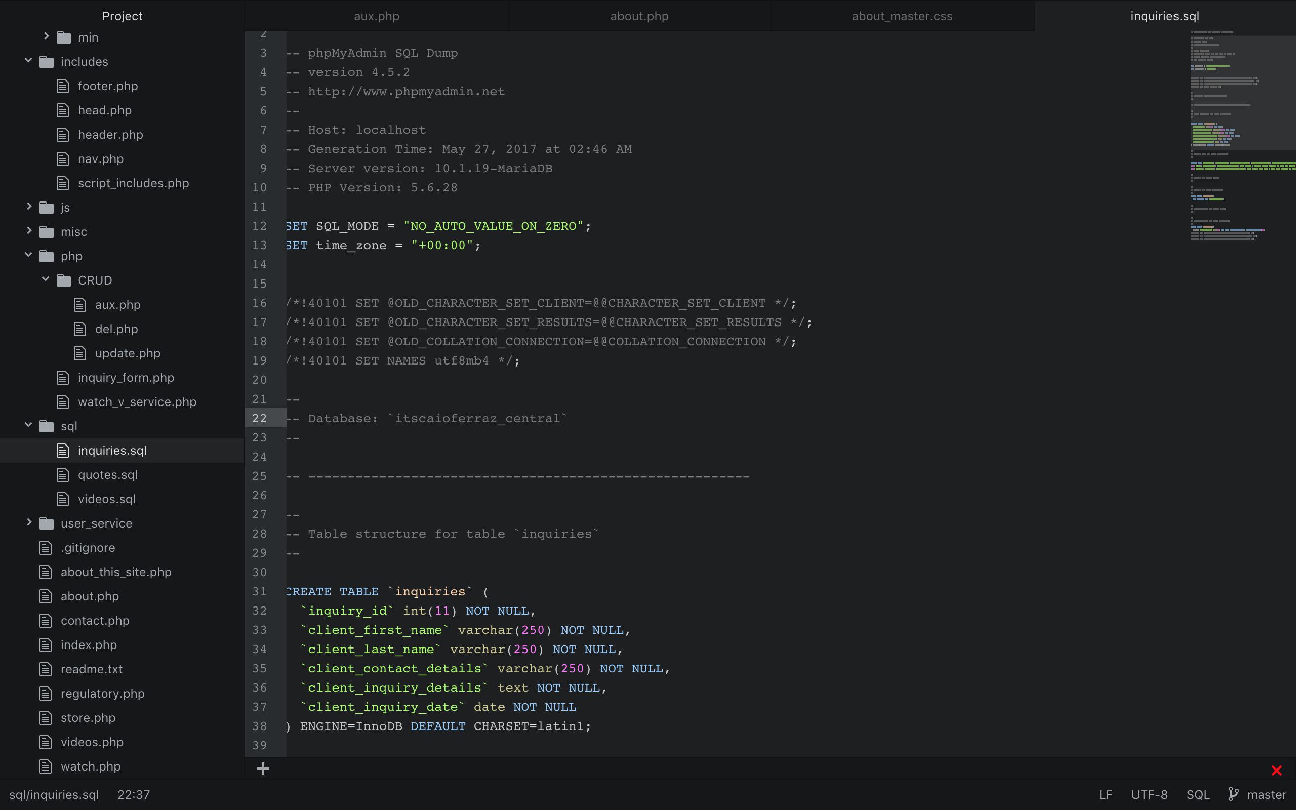

* Evidence of **acting on reflection**
  + **Claim**: Yes, I have acted on my reflection.
  + **Overview**: Acting on my reflection has been a major benefit that has allowed me not only to reflect and re-iterate my current knowledge but to take it further and act on it.
  + **Evidence**

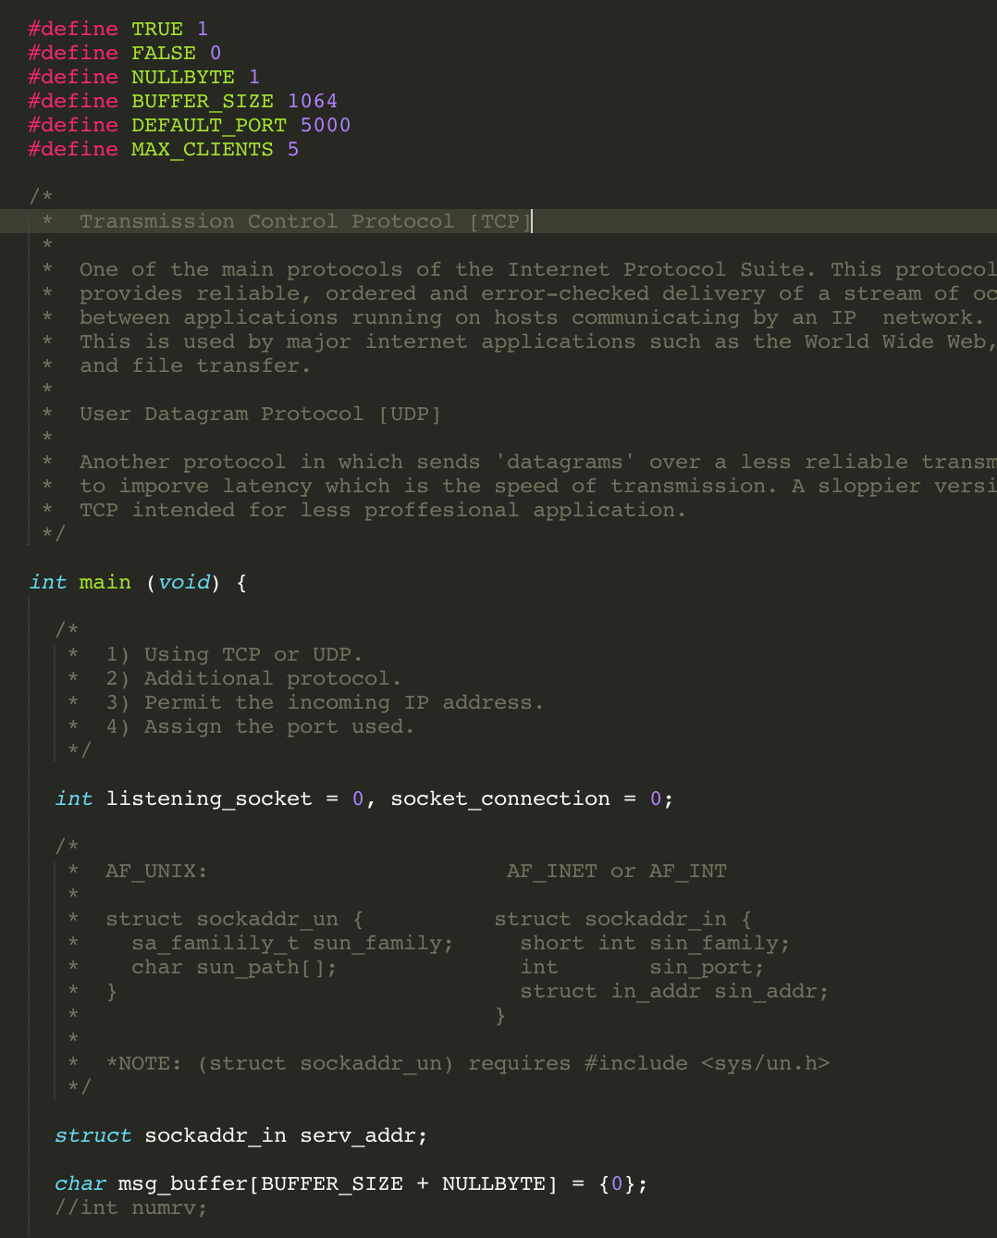

* Evidence of **improvement (**More impressive if **evidence is sustained** rather than mainly all the end.**)**
  + **Claim**: Yes, I have improved over the course of HS1917.
  + **Overview**: Improvement has been a fantastic fruitful experience which seems to always find its way to me at the start of things.
  + **Evidence**

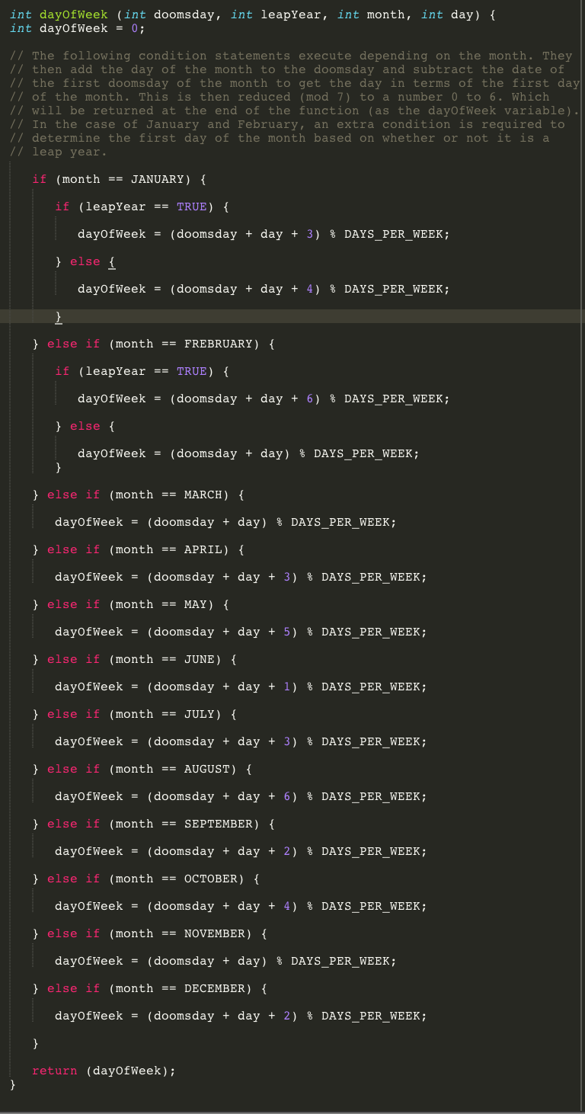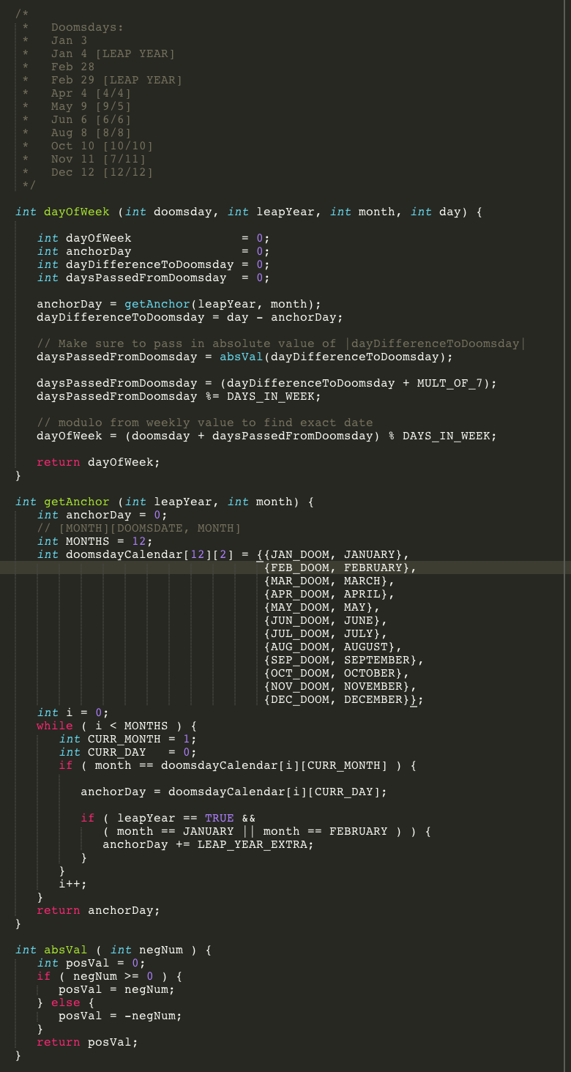

* Identifying problems and working out strategies to fix them (more impressive if **problems identified *before* the last minute**)
  + **Claim**: Yes, I can claim I have identified problems and solved them using specific strategies such as dynamic programming.
  + **Overview**: Pioneering different optimal strategies of fixing problems has been a constant experience throughout this course.
  + **Evidence**

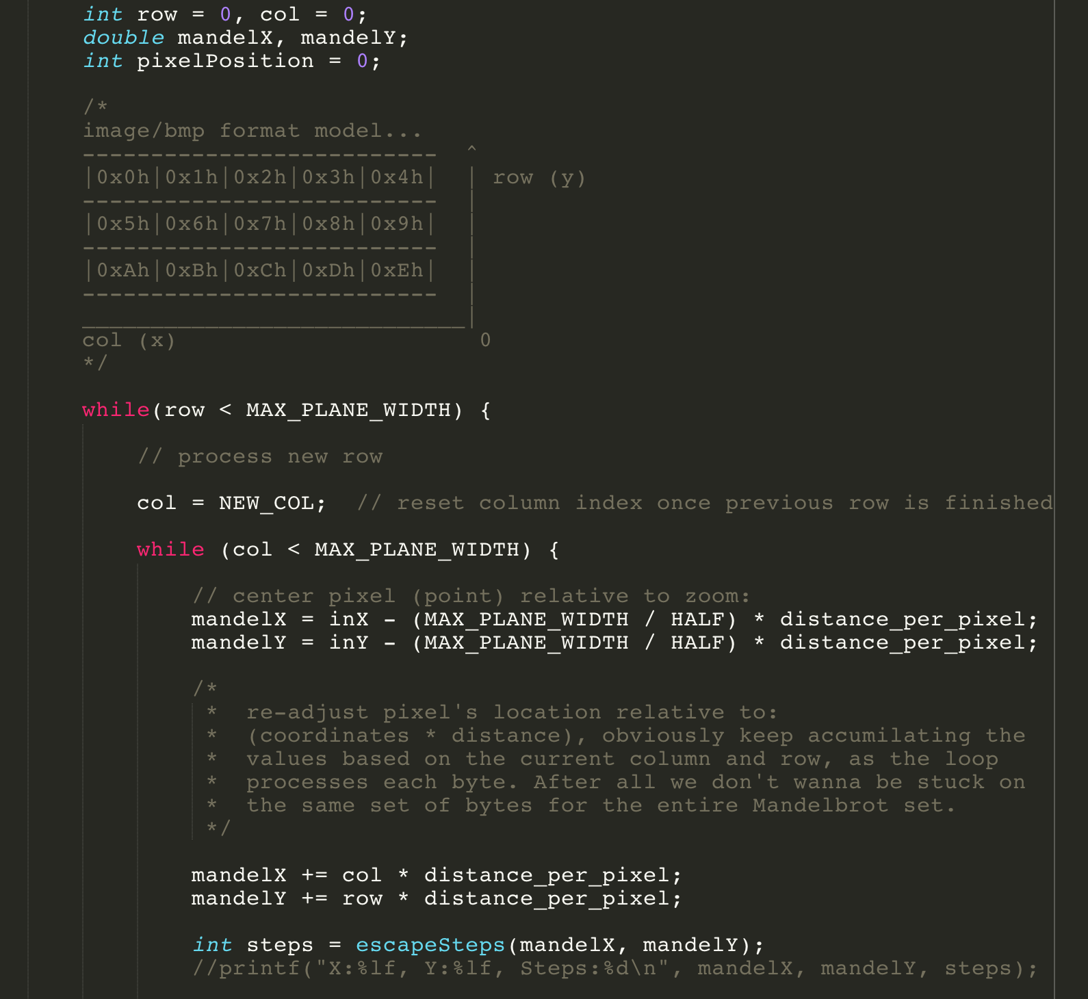

* **Helping others** improve their own craftsmanship
  + **Claim**: Yes, I have helped others improve their craftsmanship.
  + **Overview**: I has been not only a positive experience fixing my own craftsmanship but also helping others to fix theirs’s.
  + **Evidence**



* Evidence of **personal change**
  + **Claim**: Yes, I have experienced personal change thanks to this amazing course!
  + **Overview**: It has been a growing experience, getting to know new and different people and learning to be more flexible in terms of teamwork.
  + **Evidence**

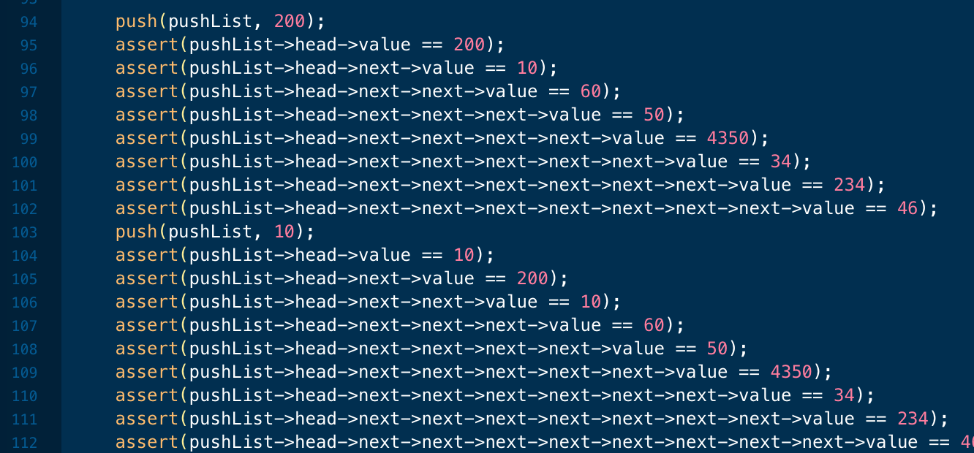

* Evidence of **understanding what is craftsmanship**
  + **Claim**: Yes, I can claim that I have understood the key concepts of craftsmanship.
  + **Overview**: Prior to this course I only had very naïve experience with craftsmanship, however now I do know how to properly layout code and make it aesthetically pleasing.
  + **Evidence**



* Compelling evidence of a **commitment to quality in other aspects of life outside of c code**
  + **Claim**: Yes, I can claim that I have made commitment to quality in a general sense in my life.
  + **Overview**: I have taken all the core principles of artisanship we have learned here at HS1917 and used them with my projects and personal ventures. It has been one heck of a rewarding experience.
  + **Evidence**

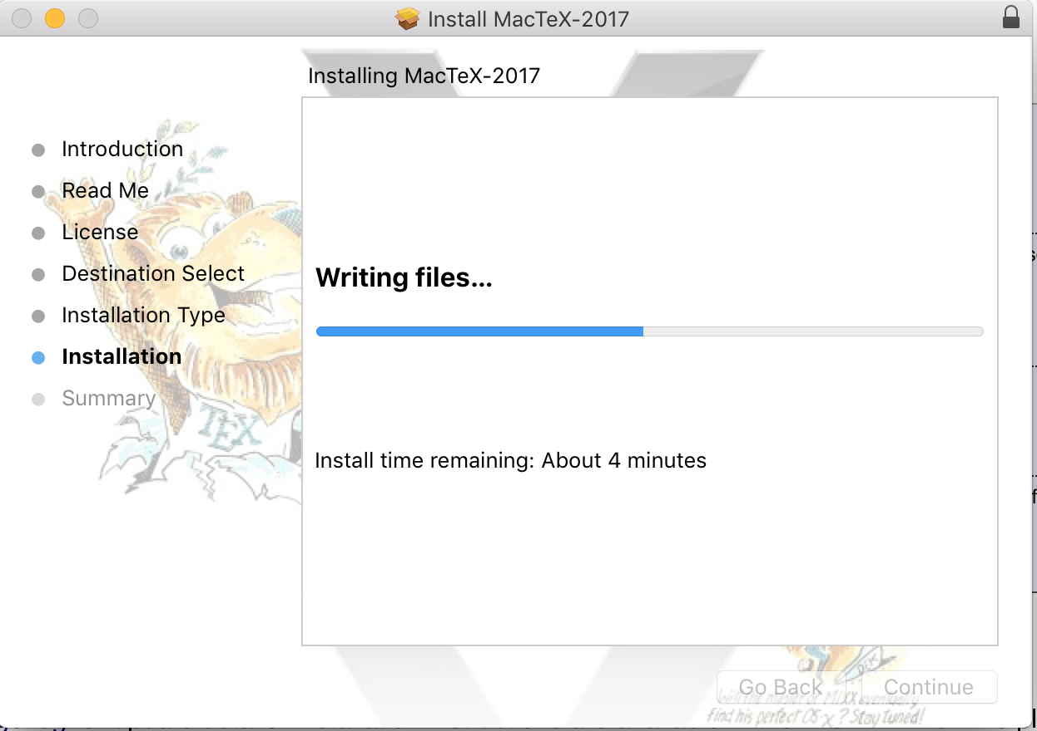

* Compelling evidence of a **commitment to testing in other aspects of life outside of c code**
  + **Claim**: Yes, I can claim that I have made commitment to quality in a general sense in my life.
  + **Overview**: I didn’t plan on just learning these new things here at HS1917 to not be able to use them in later ventures. The test-driven approach we use here, I have adopted with my software design class and my personal projects.
  + **Evidence**

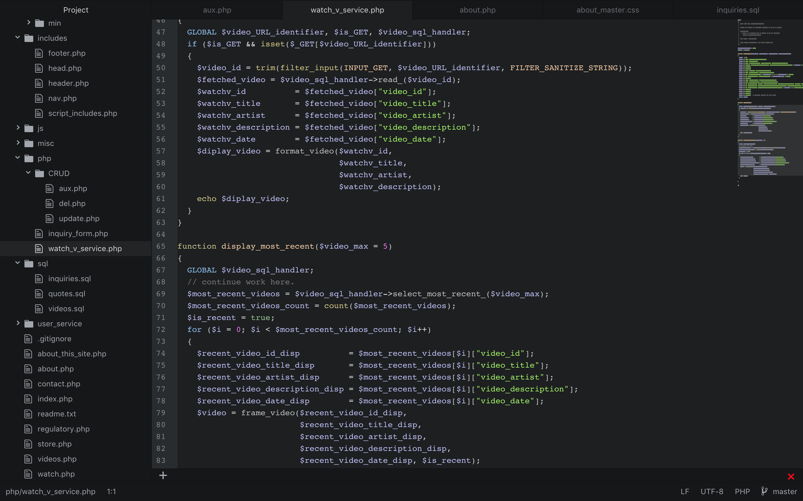

* Evidence of **debugging skills** and of**reflecting on and learning from mistake**
  + **Claim**: Moderately, I have plateaued in terms of GDB debugging skills.
  + **Overview**: I haven’t had the time to be able to firstly install GDB and learn how to use it. This has left me dark on the idea of debugging tricky little seg-fault generating concepts such as linked lists.
  + **Evidence**

